The Spiral Architecture Driven Development of Software Product

Annotation

This article presents the author’s view of a system architecture design in the software product development; shows the most important aspects of system architecture design, the necessary activities to reduce a risk to produce ineffective architecture. Some statements in this article might be used as best practices or framework for the tailoring of own architecture driven software development process.

The article provides the Software Development Lifecycle (SDLC). The main idea of this SDLC is architecture driven development. SDLC is based on the spiral development model by Boehm, the best world-wide standards, such as Rational Unified Process (RUP), Microsoft Security Development Lifecycle (MSDL), Project Management Body of Knowledge (PMBOK) and author’s own experience in software development.

To implement spiral model principles the methods of ICONIX methodology were selected as agile and scalable methodology with optimal set of specifications and models, quite enough to develop a software product with required quality from one hand; and, from another hand, methods and activities of RUP to create a full set of software requirement specifications, especially architectural specifications with detailed requirements.

This article is overview of architectural aspects of author’s MBA’s honors degree work “Development of Project Management System Conception for Software Development Company”, which was defended in October, 2009. The architectural ideas described in the article were used in production projects. The author will be honored to share his ideas and experience with a wide audience and the author hopes it will be helpful to other specialists.

This article is intended for system architects, project and product managers, system analysts, process engineers and heads of software development departments. As addition to the article the web-site http://sadd.codeplex.com/ is created for everyone to find out practical materials to use and to discuss.

The article doesn’t pretend to be a complete guide to software development and doesn’t pretend to describe activities of all roles participated in software development projects and artifacts are created, and procedures are carried out. The article presents a main idea of software development lifecycle driven by architecture. There are several artifacts from the site http://sadd.codeplex.com that are allowed a reader to download and use them as samples.

Content
The Spiral Architecture Driven Development of Software Product 1
Annotation 1
Content 2
The Main Principles of Requirements and System Architecture Development 3
Iteration 1. Conception Creation 7
Targeting and Planning phase 7
Risk Management and Modeling phase 7
Conceptual Prototype Design and Development 8
Testing and Lessons Learning 8
Iteration 2. Architecture Design 8
Targeting and Planning Phase 8
Risk Management and Modeling Phase 9
Architectural Prototype Design and Development phase 9
Testing and Lessons Learning phase 9
Iteration 3. System Design and Implementation 9
Targeting and Planning phase 9
Risk Management and Modeling phase 9
Functional Prototype Design and Development phase 10
Testing and Lessons Learning phase 10
Iteration 4. Production 10
Targeting and Planning phase 10
Risk Management and Modeling phase 10
Release Design and Development phase 10
Testing and Lessons Learning phase 10
SADD with Microsoft SDL incorporated 11
Software Requirements Management Plan 13
Software Requirements Management Plan. Example of requirements types 14
Software Requirements Management Plan. Example of NFR types 18
Software Requirements Management Plan. Example Requirement’s attributes 19
Product Strategy Plan 22
Strategic Planning 22
Tactical Planning 22
Operational Planning (Production and Capacity Planning) 23
Bibliography 24
About author 24
Acknowledgments 25

The Main Principles of Requirements and System Architecture Development

The main idea of Spiral Architecture Driven Development (SADD) is to produce system architecture to cope with architectural and technological risks in the early iterations of the project lifecycle.

SADD is based on the spiral development model of Boehm.
The main principles of spiral development model of Boehm are:
- do not develop system specification in details before high risk elements of the system architecture are not defined;
- to produce prototypes on each iteration to mitigate risks;
- to pay little attention to details while development of the system is possible without details.

SADD uses the best practices of AGILE:
- to produce prototypes implement reduced-functionality system to mitigate a risk to create the system with non-verified requirements;
- to produce prototypes that gradually evolve to become the final system in the later iterations to mitigate risks with changes in the requirements and to involve a customer in the development process.

SADD uses the best practices of RUP:
- develop iteratively;
- manage requirements;
- use component architectures;
- model visually;
- continuously verify quality;
- manage change.

SADD uses practices of PMBOK:
- to develop and maintain a risk management plan;
- to identify, to monitor, and respond to risks; to nominate a project member to the risk and by the help of risk prevention plan to point at role activities and artifacts which can prevent the risk;
- to develop requirements development plan as a part of the project management plan.

From the author’s point of view to cope with architectural and technological risks is more useful:
- the iterative approach of building, testing, and evaluating executable versions of the system in order to cope with the problems and resolve risks and issues as early as possible;
- the use-case model primarily sets the functional requirements on the system, and is used as an essential input to analysis and architectural design;
- architectural analysis and architectural requirements management in the early iterations of the project lifecycle; development of the architectural mechanisms;
- to develop and maintain a list of architectural risks; to reconsider this list on meetings for architecture decisions;
- to produce executable prototypes in the early iterations of the project to check nonfunctional requirements such as performance and interoperability.

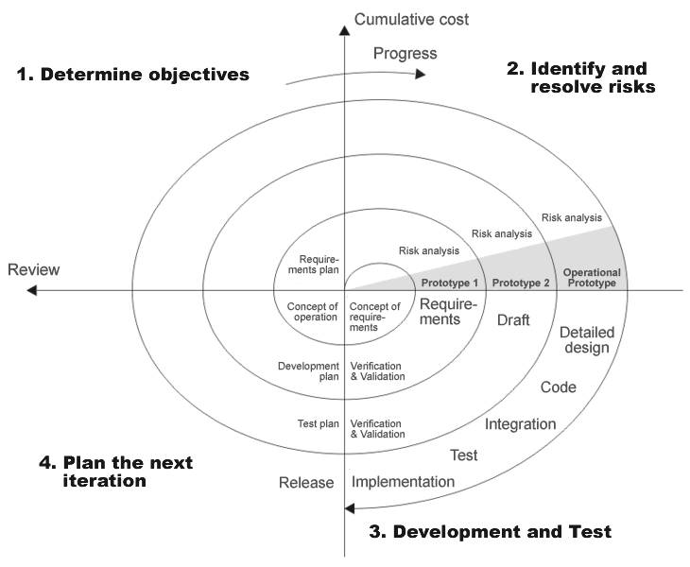
Figure 1. The Boehm’s Spiral Model

By way of methods fulfilled principles of SADD have been chosen:

- the best practices of Rational Unified Process (RUP), including activities and artifacts of Analysis & Design Discipline; the idea of architectural mechanisms and VOPC (View of Participated Classes) diagram;
- the best practices of ICONIX methodology, including a user interface prototype and a robust diagram of use case;

You can read the presentation SADD-MTHD-04-Analysis and Modelling.ppt which give you information about models used in SADD and descriptions of main roles.

Software Development Lifecycle of projects used Spiral Architecture Driven Development is shown on the Figure 2.

The Software Development Lifecycle of the project based on SADD (SDLC SADD) accentuates to produce architecture of the system and to cope with architectural risks in the early iterations of the project life.
SDLC SADD takes into account that a product will begin to produce after some decisions about future and development of the product are made.

Iteration is a sequence of activities with a common target to develop a system prototype or a final commercial version of system. Each twist of the spiral on the diagram shows software development iteration (iteration). Each segment of the spiral shows a development phase ended with important results.
Each iteration is finished by a control point, depicted as a solid rhombus. The name of this point coincides with the name of previous iteration.

The big cursors in the corners of the diagram are phases of iteration. The text on these cursors has a custom color.
Several phases may execute in parallel with other phases. It is shown by help of additional arc above the line of iteration.

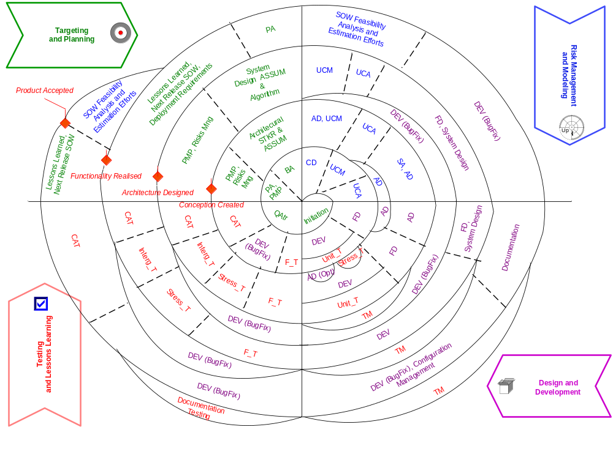
Figure 2. Software Development Lifecycle is based on the Spiral Architecture Driven Development.

Abbreviations are used in the Figure 2. Software Development Lifecycle based on the SADD:
- PA – preliminary analysis
- PMP – project management plan
- BA – business analysis
- CD – conceptual design
- UCM – use case modeling
- UCA – use case analysis
- FD – functional design
- AD – architectural design
- SD – system design
- DEV – development
- Unit_T – unit testing
- Stress_T – stress testing
- F_T – functional testing
- CAT – customer acceptance test
- Integr_T – integration testing
- TM – test management
- SOW – statement of work
- Risk Mng – risk management
- STKR – stakeholder
- ASSUM – assumption
- UREQ – user requirements
- QAtr – quality attributes – nonfunctional requirements.

Let us take a glance at the iterations of SADD. Subsections inside iteration are corresponded with four main phases of spiral development.

Iteration 1. Conception Creation

The purpose of this iteration is to create a system conception.
Quality attributes are identified, and architecturally significant stakeholder requests are analyzed for their used as the basis if system-architecture conception. The architectural prototype is validated to satisfy quality attributes, particular performance, and loading. The result of this iteration is that an executable architectural prototype implements the basic use-case flows.

Targeting and Planning phase
In the beginning of the Targeting and Planning Phase quality attributes for the product are identified. In particular performance requirements, interoperability requirements and deployment requirements are analyzed because they affect architecture. During the Preliminary Analysis all Business Visions (BVISION) and Technical Visions (TVISION) of the product are analyzed. BVISION is a result of producing “The Product Creation and Development Conception”. TVISION is a result of producing “The Product Architecture and Technologies Conception”. For details see the subsection “Tactical Planning” of the “Product Evolution Plan” section of this article. After that the Project Management Plan is created including the Software Requirements Management Plan. Architecturally significant stakeholder requests are identified and analyzed during the Business Analysis activity. The article “SADD-MTHD-02-Architectural Requirements.doc” describes practical methods of architectural requirements and architecturally significant stakeholder requests identification and analysis.

Risk Management and Modeling phase
“The Product Creation and Development Conception” and “The Product Architecture and Technologies Conception” produced during the tactical planning are clarified (see the section “Product Evolution Plan” of this article). After the Conception Design (CD) activity ended the Use Case Modeling (UCM) and the Use Case Analysis (UCA) activities are executed. These activities are from the Rational Unified Process (RUP). The architecturally significant use cases are deeply analyzed.
If the system has a rich interaction with users then ICONIX practices to create user’s prototypes are used. These user’s prototypes are discussed with users to clarified use cases. Robust diagrams (from ICONIX) are created to validate use cases. In parallel with Use Case Modeling activity the Architecture Design activity is began. During the Architecture Design the Architecture Analysis and the Architecture Prototype Creation activities are executed. These activities are described in the section “Architecture Development Methodology” of the article “SADD-MTHD-01-Architecture Development.doc”.

Conceptual Prototype Design and Development
Functional requirements are analyzed and developed during the Functional Design activity of this phase. Architecturally significant functional requirements are developed deeply. Activities “Analysis Behavior”, “Refine Architecture” and “Design (Design Components, Design the Database, Design Services)” are described in the section “Architecture Development Methodology” of the article “SADD-MTHD-01-Architecture Development.doc”.
Architectural mechanisms are elicited and analyzed during the stage. For details see “SADD-MTHD-03-Architectural Mechanism.doc”
Unit tests (Unit_T) are executed in parallel with code development. The following activities are also executed in this phase: stress testing (Stress_T), performance testing and interoperability tests. According to the results the architecture is optimized (AD (Opt)). A test manager defined the test strategy of architectural prototype, tests plans and tests cases during the activity Test Management.

Testing and Lessons Learning
Functional Testing (F_T) of prototype is executed during the Testing and Lessons Learning phase. Usability testing is executed during the Functional Testing. Final test results are used for a code stabilization (Development (DEV (BugFix)). The Customer Acceptance Test (CAT) for architectural prototype is checked.

Iteration 2. Architecture Design

The purpose of this iteration is to develop system architecture. The technological and quality-attribute achievement risks are identified, and a risk-mitigation plan is created. Architecturally significant stakeholder requests are analyzed to identify new assumptions that have an effect on the system-architecture design.
The result of this iteration is that an executable architectural prototype implements 20 to 30 percent of alternative use-case lows.

Targeting and Planning Phase
The main point of the Targeting and Planning Phase is architecture development. The Architecture Design iteration is started from updating of document “Project Management Plan” during the Project Management Plan activity. Then risks are identified, risk avoidance strategies and risk mitigation strategies are created, the Risk Avoidance Plan and the Risk Mitigation Plan are produced. The main goal of this phase is to identify and to resolve the most critical architectural problems and risks of achievement of product quality requirements. You can examine examples of architectural problems in the section “Lessons Learned and Best Practices of Architectural requirements development and management in project “ZZZ” of the “SADD-MTHD-02-Architectural Requirements.doc”. You can examine examples of risks of achievements of product quality requirements in the section “Requirements Management and Development” of the “SADD-MTHD-04-Analysis and Modelling.ppt”. During the “Architectural STKR and ASSUM” activity other architectural stakeholder requests are detailed, new assumptions and constraints are identified.

Risk Management and Modeling Phase
The main activity on this phase is the architecture design (AD). This activity implies the following activities: “Refine Architecture”, “Design Components, Design the Database, Design Services” and “Architecture Specifying”. These activities are described in the section “Architecture Development Methodology” of the “SADD-MTHD-01-Architecture Development.doc”. A system architect and a software architect can find architecture specification templates in this document. Another useful tool for architecture development is architectural mechanisms. During the architecture design activity (AD) the model of architectural mechanisms is created, architectural mechanisms are implemented including test cases. You can find the example of using architectural mechanisms in the “SADD-MTHD-03-Architectural Mechanism.doc”. In parallel with the use case modeling (UCM) and use case analysis (UCA) activities the system analysis is executed. Architecture is clarified according the system analysis result during the architecture design (AD) activity. The presentation “SADD-MTHD-04-Analysis and Modelling.ppt” describes types of models and their purposes, relationships between models and different types of requirements. During the whole phase found defects are corrected.

Architectural Prototype Design and Development phase
The architecture design activity (AD) is finished by producing architecture document. Functional requirements are detailed during the functional design activity (FD). After that the development (DEV) and the unit testing (Unit_T) activities are began in parallel. After the functional design activity the test management activity (‘TM’) is began. During the test management activity a test manager creates the prototype test strategy, prototype test plans and test cases.

Testing and Lessons Learning phase
According to the Test Strategy and prototype test management plan the following activities are sequentially implemented: F_T (Functional Testing), Stress_T (Stress testing), Integr_T (Integration testing) and code stabilization. After code stabilization the CAT (Customer Acceptance Test) is implemented.

Iteration 3. System Design and Implementation

The purpose of this iteration is to implement the functionality of the system.
The risks that are related to satisfying system functions and user requirements are identified and mitigated in a new version of the architectural prototype. All assumptions and constraints are analyzed. Functional testing and integration testing are performed. The result of this iteration is that an executable architectural prototype implements 40 to 60 percent of alternative use-case lows.

Targeting and Planning phase
On this iteration the main attention is given to the functionality development. The iteration is started from the project management planning when Project Management Plan is updated. After that the risk management is conducted where risks are elicited and mitigation and contingency plans are created. The risks of user requirements achievements and functional requirements realization are the goal for this iteration. After that the system technological assumption and constraints are analyzed, and algorithms are defined (System Design ASSUM & Algorithm activity). The realization of such assumptions and algorithms is a main goal of the iteration too.

Risk Management and Modeling phase
The main activity on this phase is use case modeling and use case analysis (UCM, UCA), all tfunctional requirements are developed (FD activity). During System Design activity the system realization model is created. This model includes itself all system design and architectural requirements, data models, class models, implemented algorithms, system protocols and interfaces (System Design activity).

Functional Prototype Design and Development phase
Here the functional requirements (FD activity) and a system realization model (System Design activity) are finalized. If there is no completed architectural specification by this moment, they are created (see SADD-MTHD-01-Architecture Development.doc). As the system realization model is finished the code development is started (DEV activity) with the Unit Testing (Unit_T activity). In parallel the Test Management (TM activity) is being provided by Test Manager, who creates test strategy, test plans, test scripts and test cases.

Testing and Lessons Learning phase
In according to the developed test strategy and test plans, on this phase the different test types are conducted: functional testing (Functional_T), stress (loading) testing (Stress_T), interation testing (Integr_T). After code is stabilized, the Customer Acceptance Test is planned and prepared.

Iteration 4. Production

The purpose of this iteration is to stabilize code.
The deployment requirements are developed and met during this iteration. The system is validated by tests.
This iteration is intended to plan the development of the next version of the system, create system requirements and architecture specifications, and prepare the system for deployment. The Statement of Work for the next version of the system is created. The result of this iteration is a fully functional and documented version of the system.

Targeting and Planning phase
The main point of the Targeting and Planning Phase is preparing current release for production and planning of the next release (version) of the system. The Production iteration is started from lessons learned conducting and analysis of all postponed change requests during the project lifetime. The SOW (Statement of Works) of the next release of the system is created based on these change requests, which are still necessary. The main goal of this phase is to incorporate all the deployment requirements (deployment scripts, default settings, etc.), but the Preliminary Analysis (PA) of the SOW for the next version of the system is performed during this phase too. It’s extremely important from the perspective of new change requests to the Project Portfolio and / or to the Operational Plans (see. Chapter “Product Strategy Plan”).

Risk Management and Modeling phase
The main activity on this phase is the feasibility analysis of the SOW created, WBS creation and rough order of magnitude estimation of the next release costs. If there are gaps in current release functionality they are covered by the final code development. In parallel all the found defects are corrected.

Release Design and Development phase
In case if SADD is used to develop the final commerce release, on this phase the production version of the system is completed. Otherwise, if SADD is implemented to develop a non commercial version of the system, the completed solution as a delivered functional prototype is finalized. From the SDLC perspectives it is important that when the functional development is finished, the code stabilization (DEV activity) and documenting (Documentation activity) is started. The installation is composed from the compiled source code, based on the deployment requirements and including automated scripts and wizards to setup the system, documentation for the users, administrators and configuration managers. In parallel the Test Management (TM activity) is started. Test manager finalizes the test strategy including a final Customer Acceptance Test, and creates all the necessary test scripts, cases and test data.

Testing and Lessons Learning phase
On this phase the Documentation Testing is performed and code is totally stabilized (DEV (BugFix)). When the code is stabilized, the Customer Acceptance Test is performed.

At the conclusion, it should be noted that you may find out the methods how to develop architecture and the list of architecture activities in the SADD-MTHD-01-Architecture Development.doc. You may also download and tailor by you own the architectural specifications’ templates on sadd.codeplex.com.

SADD with Microsoft SDL incorporated

The Microsoft Security Development Lifecycle (SDL) looks like the one shown in Figure 3.
You will find out the meaning of the MSDL activities in the original description of MSDL.

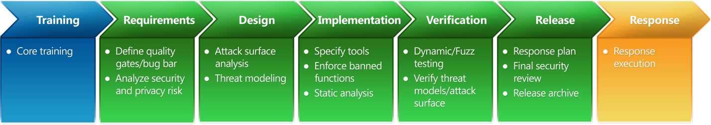
SADD with MSDL incorporated is presented below.
Figure 3. Secure software development process model at Microsoft

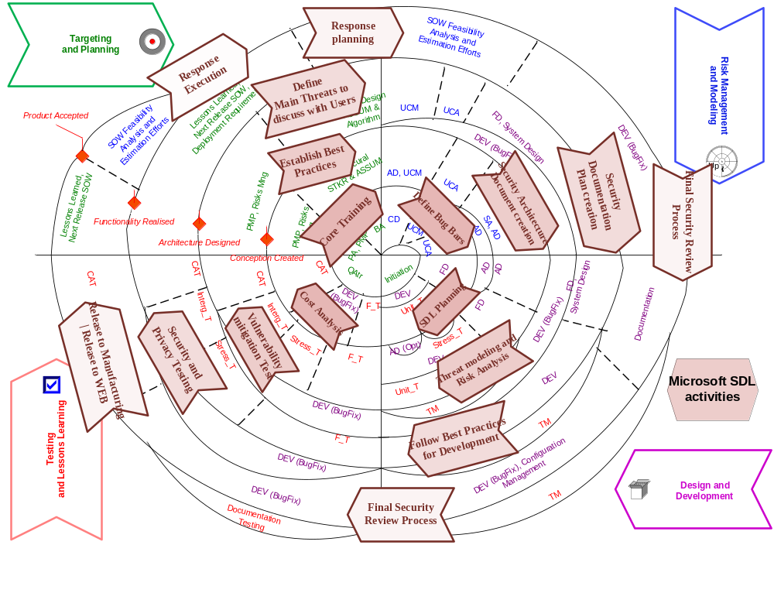
Figure 4. SADD SDLC with Microsoft SDL incorporated
.

Software Requirements Management Plan

According to the best practice RUP “manage requirements” and Planning process Group of PMBOK for effective requirements management, including architectural requirements, it is strongly recommended to define all the requirements management questions in the form of Requirement Management Plan (RMP) and formally approve it with all stakeholders. According to PMBOK, the Requirements Management Plan is a part of the Project Management Plan. This plan is created during the “Conception Creation iteration of the SADD on the Project Management Planning (PMP) phase and is being updated during the project lifetime and must be up to date and approved by Project CCB (Change Control Board) at the end of every “Targeting and Planning” phase of the SADD iteration. It’s critical for the right project management, but even if there is a functional matrix in the organization, I recommend you to define RMP for every release.

It’s common practice to have a RMP template as the part of the organizational assets and to tailor it in the project.

The RMP template may consist of the following main chapters describing how to work with the requirements in the project:

- Requirements analysis and project management. This chapter describes part of the project lifecycle during which requirements are developed;

- System Analysis and Modeling. This chapter describes models with the purpose and the management plan, which are base for system analysis;

- Requirements Development. This chapter describes all requirements types which are created in the project, their purposes, traces and attributes. Different requirement types are need for effective system development because of system design accenting on the specific requirement types development and management. The number and purpose of different requirement types are regulated by system analysis methodology of the project. It’s common practice to elicit requirements of the different levels, such as business level, functional level and system design and realization level. Besides different requirement types are necessary to make special requirements management tools effective and valuable. If you use such tools in the project to manage requirements the following advantages are possible:
- to structure requirements and organize different views of the same requirements (for example, by project roles, by subsystems, by initiator, by state, etc…);
- to manage requirement traceability. It makes sense if there is strong quality requirements to the end product and / or if the Customer pays the special attention to the formal approval of the requirements specification and to the functionality of the system;
- to manage stakeholders’ change requests to the functionality and requirements;
- to manage requirements review and approval process.
If you do all these activities you reduce the risk of non-actual, incorrect or contradictory requirements developments, and, therefore reduce the risk of the development of the system which won’t be satisfying the stakeholders’ expectations
- Requirements Management. This chapter describes all aspects of the requirements management: requirement attributes management, responsibilities of the project roles in the requirement development process, requirement lifecycle for every requirement type, shows all the possible requirements traces and what these traces will be created for.
- Requirements Change Management. This chapter describes how change requests to the requirements and functionality will be managed in the project. It also shows and describes the requirement baselines.
- Requirement Specifications. This chapter describes all requirements specifications which will be created in the project. The final version of this chapter must be in accordance to the Document Management Plan. The Document Management Plan is the project artifact which describes all project artifacts (specifications, documentation, files, etc…) and their purpose, location, state, deadline, list of reviewers and approvals, and goals and responsibilities of the project team for every document.
- Requirements Analysis Process Management. This chapter describes the common rules and regulations how to project roles are co-worked to the successfully develop requirements. The company policy for the business domain learning and for the continuous requirements development process improvement is tailored to the project ones in this chapter also.
It should be noted that RMP for the Project in not the same as the RMP for the whole Product. These two documents are covered different management aspects. RMP for the Product regulated how to develop requirements of the Product level and is described below in the “Product Strategy” chapter.
Below you may find out the examples of the RMP for the Project level.

Software Requirements Management Plan. Example of requirements types
Requirement Name | Abbreviation | Trace to | Trace from | Description (Purpose)
Answers | ANSW | Any requirement type  (on the whole trace to STKR, UREQ) | - | To store original answer from the stakeholder and / or expert and trace how it is transformed to another requirements. It allows knowing the reason why the concrete requirements are exist in the project and where it is traced from.
Stakeholders’ Requests | STKR | BR  BRULE  ASSUM  BVISION  UC | ANSW | To form full and consistent set of stakeholders’ requests.  Traces to BR and BRULE are to check on consistent.
Business Requirements | BR | BVISION  ASSUM | - | To form full and consistent set of business requirements. Business requirements are high level goals of the organization for the system usage and shows why the organization is need in the system. In other words, they define the business goals which the organization is planned to reach with the help of the developed system.
Business Rules | BRULE | BVISION  ASSUM | - | To form full and consistent set of business rules. Business rules are specific regulations and lows which are mandatory for the system for the business reasons.
Assumptions | ASSUM | TVISION | STKR  BR  BRULE | They are outer constraints to the system which a system analyst detected from the business environment analysis. Business environment here is stakeholder’s requests, business rules, and business requirements.
Technology Constraints | TECH | TVISION | - | They are the result of the system feasibility analysis performed by a system architect. They are: technological constraints, development platform constraints, system development and deployment environment constraints.
Certification Requirements | CERT | BVISION | - | Requirements of the Certification Regulators if the system must be certified after released.
State (government) Standards | STSTD | BVISION | - | The government requirements, regulations and standards for the systems of the developed system kind if they are exist.
System Characteristics | CHAR | BVISION  TVISION | - | Useful system characteristics and capabilities of the previous version of the same system or of the same system kind to be inherited / incorporated accordingly.
Business Vision | BVISION | UC | STKR  BR  BRULE  SERT  STSTD  CHAR | Business Vision how to develop product from the perspective of the business needs, stakeholders’ requests, certification requirements and best characteristics of the same system kind.  This kind of requirement encapsulated itself all the business specific requirements to the system. It may be used as the result of the business analysis activities.
Technical Vision | TVISION | UC  NFR  CHAR | ASSUM  TECH | Technical Vision of the required Business Vision realization.  It is considered all the stakeholder requests, business constraints from the one hand, and, from the another hand, it is considered modern platforms, technologies and development tools.
User’s Requirements | UREQ | UC  NFR | ANSW | Requirements to the system from its direct end-users.
Use Cases | UC | FR  NFR | STKR  BVISION  TVISION  UREQ | Use case of the system from the part of an Actor. Actor is User, Other System or any Device who uses the system from its own purposes. The use case must give the significant result to the Actor.
Functional Requirements | FR | - | UC | Statement which is testable and answers to the question “what the system can do” and describing the system functionality in the form of functional requirements: “The system must …”
Nonfunctional requirements | NFR | - | UC  TVISION  UREQ | Statements which often contains the qualitative values which must be achieved by the system during its work.
Therminology | TERM | Any requirement type | - | System terms

The figure 5 shows the diagrams of main requirements types.
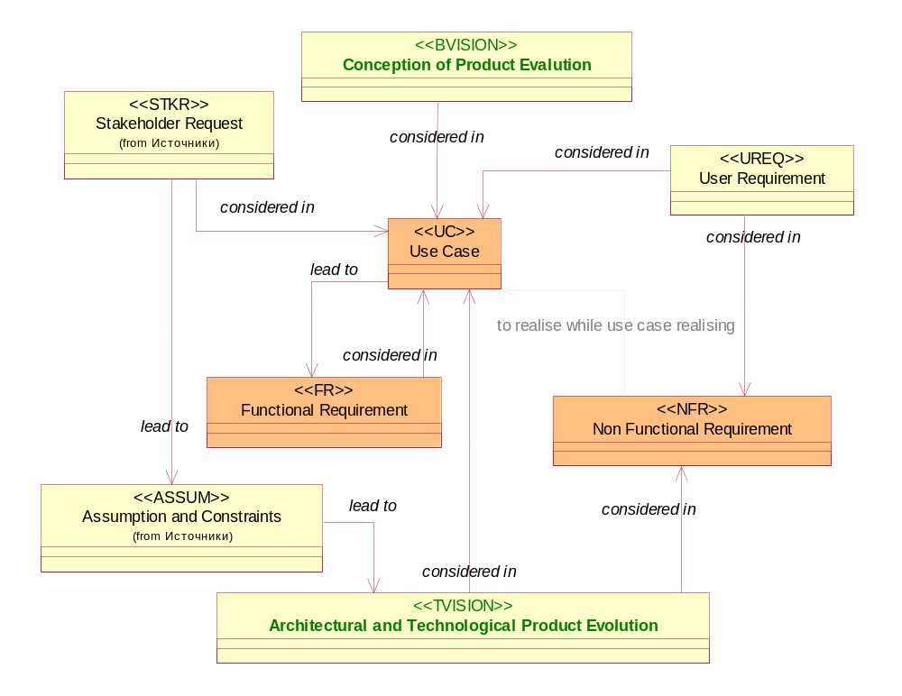
Figure 5. Main Requirements Types from Software RMP

Software Requirements Management Plan. Example of NFR types
The Non Functional Requirements (NFR) are often under responsibility of different project roles. This is the reason why it is recommended to use separated requirement types. The table below shows these non-functional requirement types as an example.
NFR Requirement Type Name | Short Description
User Interface Requirements | Usually are elicited by system analyst and GUI designer.
System Interface Requirements | Usually are elicited by system analyst, system architect and system designer.
Documentation Requirements | Usually are elicited by documentation manager and technical writer.
Data Requirements | Usually are elicited by system analyst, system architect and database architect / designer.
Environment Requirements | Usually are elicited by system analyst, system architect and system designer.
Hardware Requirements | Usually are elicited by system analyst, system architect, system designer and technical experts.
Software Requirements | Usually are elicited by system analyst, system architect and system designer.
Deployment Requirements | Usually are elicited by system designer and configuration manager.
Productivity Requirements | Usually are elicited by system analyst, system architect and system designer.
Reliability Requirements | Usually are elicited by system analyst, system, architect and system designer.
Scalability Requirements | Usually are elicited by system analyst, system architect and system designer.
Security Requirements | Usually are elicited by system analyst, system architect, system designer and security manager.
Ergonomic Requirements | Usually are elicited by system analyst, usability specialist and GUI designer.
Licensing Requirements | Usually are elicited by license manager, configuration manager.
Compatibility Requirements | Usually are elicited by system analyst, system architect, and system designer and configuration manager.
Support Requirements | Usually are elicited by system designer and configuration manager.
State (Government) Requirements | Usually are elicited by product manager, license manager, security manager, business analyst and system analyst.
Localization Requirements | Usually are elicited by product manager, localization manager, business analyst, system analyst, usability specialist and GUI designer.

Software Requirements Management Plan. Example Requirement’s attributes
Every requirement type may have the same attributes which are presented in the table below.
Attribute Name | Purpose | Possible Values
Priority | Priority to elicit, realize and test the requirement. | Hot – urgent – the requirement must be realized urgent. This priority usually is used to make a management decision. The manager may directly say “just do this requirement right now”.  High – if there is no “hot” requirements the requirements with this priority must be done firstly.  Medium – the secondly realized requirements.  Low – these requirements are elicited, realized and tested if there are no more “high” or “medium” requirements.
Complexity | Complexity to realize.  There is no testing complexity estimation, including test environment preparation and test data preparation, in this attribute. | Challenge – this means that the requirement is architectural significant and the realization of this requirement may lead to the serious technical risks. Usually it is a kind of a signal to the team that there must be done specific research works and brainstorming. It is a challenge for the team.  Solution – this is also architectural significant requirement, which is related to the solution core.  Normal – usual requirement. There is no need to find out the architectural solution for such requirements.  Easy – the requirement is like quick change which may be / may be not checked by traceability matrixes.
Cost | Total cost of the efforts to realize requirements.  May be changed in the result of Impact Analysis during Project Initiation and Evaluation process.  It is actual for the UREQ, UC, FR and NFR specified below:  - security;  - compatibility;  - reliability;  - productivity;  - system interface;  - software (component / module) interfaces;  - user interface;  - documentation;  - data;  - certification;  - localization. | Minimal value not less than 1 hour.
Assigned To | Project team member who is to work with the requirement at the moment.  When requirement status is changed this attribute must be analyzed by project manager and often must be reassigned to the other project role in according to the requirement lifecycle. | The person who is assigned to work on the requirement can not be outside of the project and must be a project team member.
Status | Requirement status (state).  The attribute value is changed by project team member whom this requirement is assigned to. | For every requirement type there is its uncial state machine.
Target Release | Release number where the requirement is planned to be incorporated. | Target release shows the system / software version number f.e.1.0.0.
Phase | Project phase when the requirement must be incorporated by. | For example, phase 1- architectural prototype, phase 2 – first commercial version with the Target release number 1.0.0.
Cause | This attribute to note the Enhancement Requests number, feature number, protocols, comments to explain why the requirement status has been changed, etc… | Free text usually with the length no more than 255 characters.

Product Strategy Plan
For the purpose of product architecture and functionality scope planning and management, the Product Strategy Plan (PSP) is created. One of the most important parts of this plan is the Product Requirements Management Plan (PRMP), which describes how the requirements development and management is going to be executed to make the product development feasible.

The PSP is based on the principle of concentrating on analysis at product life cycle milestones. The main target for analysis is a portfolio, which describes every product of the company, products' target clients and markets, and plans for new functionalities (features) for several future releases. This list of product features must contain the description of target market, product's purpose, architecture and technology for every product of the company.

PSP and PRMP are created via triple level planning, the main point of which is a continuous movement from strategic objectives among the product's purpose, architecture and technology, through tactical planning, business and technology visions' creation, and determining of variety of commercially profitable product functions (features), to a project portfolio and operational plan, which describes the company’s capabilities challenges to make the new competitive advantages achievable.

Strategic Planning
During this stage marketing, product development and architecture strategies are created.

The main goal of creating the marketing strategy is to determine the market segment, to which a new product could be released for and to define some new, requested by the market, existing products' development trends. From PRMP's perspectives, the requirements, describing the current market demands, available products on the market, target customer groups for these products, and customer business specific are developed. All the collected information and developed requirements are transformed into a set of desirable product characteristics (CHR requirement type).

The point of creating the Product Development Strategy (PDS) is to define the objectives and trends of product's development from the clients' perspective, new legal regulations and client's business.

Business analyst, legalist and marketing manager analyze the market, clients' business and their company's business to determine the business requirements.

As a result, they get the list of Business Rules (BRULE) and Business Requirements (BREQ)

When a unique product is being developed, a project may be executed using the simplified scheme - no strategic, technology or operational planning is to be performed. In this case, you can start with the project initiation to define business rules and requirements (BR and BREQ) and then execute the project in accordance with approved methodology (f.e. SADD). But the more accurate way from the strategic product development perspective is to define all the Enhancement Requests (ER) from every client and to form projects to implementing these requirements in Project Portfolio, balancing ERs from different clients and with the defined product evolution trend. Only this approach will lead to well balanced Project Portfolio which will realize ERs elicited from all clients, their business requirements and new legal restrictions and regulations.

The main purpose of creating the Architectural Strategy (AS) is to define the objectives and trends of products' development from new software development technologies, existing on the market perspective. When the AS is being created, the product architecture is analyzed in order to discover it's possible improvements, taking into account any new technologies which could be used to make it more productive and efficient. As a result, a set of unique Research and Development requirements (RDREQ) is developed, to reflect all the desirable architectural changes in products and its' components or development process.

Tactical Planning
When tactical planning is executed, the Product Development Vision is created by the product manager and the Product Architecture Development Vision is created by the product architect (system architect).

The Product Development Vision (PDV) contains Business Vision type of requirements (BVISION), created as a result of Clients' Enhancement Requests analysis, and based upon marketing research outcome (detected desirable product characteristics). The PDV also contains summary of suggestions on order and timeframe in which the BVISIONs should be developed, which TVISIONs are to be developed simultaneously, and define the expected results from the Marketing Strategy and Product Development Strategy perspective. In other words, the PDV proposes several ways of achieving the Marketing and Product Development Strategies' objectives through a set of unique BVISIONs.

The Product Architecture Development Vision (PADV) contains TViSIONs, formulated as a result of technology trends', new customer needs and ERs analysis. The document suggests how and when TVISIONs are to be implemented, what BVISIONs are connected with these TVISIONs and what objectives will be achieved, from the point of Architecture Strategy. In other words, the PADV describes the vision of how the product must be evolved to create optimal products' components architecture.

During the Product Architecture Strategy creation and analysis, a set of management features (FEAT) is being formulated, each of which is a subset of interrelated BVISIONs and TVISIONs, from functional and architectural view point for product components and are valuable for business. A set of features is recorded as a separate chapter in Product Development Strategy.

Operational Planning (Production and Capacity Planning)
The Operational strategy serves to balance the company's capabilities and desirable profits on a strategic level.

From the profitability perspective, the Operational strategy is based upon the Product Vision and Product Architecture Strategy, including subsets of features (FEAT) as a result of tactical planning.

From the company's capabilities perspective, the Operational strategy describes the amount of material , financial and human resources, technologies and methodologies, required to implement these features.

When project portfolio is being created, the set of features (FEAT) is to be divided into subsets of interrelated features, which could be implemented and released and delivered as an independent product, or a version of a product for customers. Each set of features defines the scope of one project in a portfolio. For each project, the objectives and BVISION are to be defined. The economic efficiency (f.i. as project IRR, NPV) is to be calculated under the sales projection. During the operational planning, the set of features to be implemented may vary, some of BVISIONs and TVISIONs may be reconsidered or even declined. All these changes must be approved by Product Committee.

PRMP template and some requirements management tools are used for managing of expectations and requests of any type, from any stakeholder, which makes it possible to speed up the project's execution and easily perform the impact analysis for future planning.

Executing the activities from PRMP template leads to implementation of core products' requirements management principles such as:
- Requirements' estimation from different view points of product lifecycle to select the correct (from strategic perspectives) product versions to be created as the result of the accurate (from the economical efficiency perspectives) projects implementation:
  - requirements changes impact analysis
  - project portfolio management
- Interrelation between the project portfolio and product's lifecycle components and their structure
  - a project plan must be associated with the requirements realization.
  - If the project plan or the product structure is to be changed - each Product Committee member must approve the change and synchronize it with the whole project.
- Product requirements and other, related to the product and project data, must be actual and available for the project and product team.
The final Project Portfolio is balancing the features (FEAT), Business Vision (BVISION) and Technology Vision (TVISION).

Bibliography
- Boehm Barry W. "A Spiral Model of Software Development and Enhancement". IEEE Computer 21, 15 (May 1988), pp. 61–72.
http://en.wikipedia.org/wiki/File:Spiral_model_(Boehm,_1988).svg

- Rational Unified Process (RUP) 2006
- Rational Software Corporation. "Rational Unified Process V5.1". Cupertino, CA: Rational Software Corporation, 2001.
- Doug Rosenberg Kendall Scott: Use Case Driven Object Modeling with UML: A Practical Approach. Addison Wesley Longman, 1999.
- Doug Rosenberg: Inside the ICONIX Process (CD-ROM; ICONIX, 2001).
- Microsoft Security Development Lifecycle - Version 4.1a
- Minoli, Daniel. Enterprise architecture A to Z : frameworks, business process modeling, SOA, and infrastructure technology. Auerbach Publications Taylor & Francis Group. 2008. 481 pages. ISBN 978-0-8493-8517-9
- Slack, Nigel, Lewis, Michael. Operations Strategy. - 2nd ed. Prentice Hall, 2006
- Christof Ebert, Understanding the Product Life Cycle: Four Key Requirements Engineering Techniques, IEEE Software, May/June, 2006. IEEE Computer Society, 2006, All rights reserved. Reprinted with permission.
- C. Ebert et al., Best Practices in Software Measurement, Springer, 2004.
- M. McGrath, Next Generation Product Development: How to Increase Productivity, Cut Costs, and Reduce Cycle Times, McGraw-Hill, 2004.
- R. Cooper et al., Benchmarking Best NPD Practices: Research-Technology Management, Part I, 2004, Part II, 2004, Part III, 2004.
- C. Ebert, Requirements BEFORE the Requirements: Understanding the Upstream Impacts, Proc. Int'l Conf. Requirements Eng. (RE 05), IEEE CS Press, 2005.
- J. Giesen, A. Voelker, Requirements Interdependencies and Stakeholder Preferences, Proc. Int'l Conf. Requirements Eng. (RE 02), IEEE CS Press, 2002.
- L. Gorchels, The Product Manager's Handbook: The Complete Product Management Resource, McGraw-Hill, 2000.

About author

Short bio:

I am 36 years old, Russian, Master of Business Information, professional in software development.
Total IT operational experience – more then 15 years.
Executive positions – 5 years.
TOP management – 2 years.

I am the best experienced and highly qualified in system and business analysis, have initiated and created analytical department / group three times, have been responsible for and successfully implemented methodology, practices and procedures in three companies. Also I am experienced as a Project Manager and Program Manager. As a top manager I was a Chief of Process Office, responsible for Software Engineering Processes development based on worldwide standards CMMI, PMI PMBOK, RUP; and I was also engaged in board as a CIO.

Summary of skills:

• software manager and professional;
• experienced in targeting, strategic and business planning, developing CSF, KGI and KPIs as Balanced Score Card;
• experienced in strategic and business planning of applications development;
• specialized in business analysis, document flow and workflow analysis, system design and implementation;
• best experienced in object oriented modeling, data modeling, information systems design and implementation;
• initiative, pro-activity in offering ideas and solutions, motivated to take responsibility for decisions and implement them, capable of leading globally distributed teams in software development and software maintenance;
• able to handle an entire development processes or joins in at any stage of the on-going project

I have participated (as a project manager, an analyst, an architect) in development such systems, as: CRM, Workflow system, Enterprise Management System (Work Authorization, Project Management, Accounting, KPI monitoring), Enterprise Information portal. As a senior system analyst I have also been engaged in Boeing Reference Engineering Data Automated Retrieval System development project, - the most challenged project of Luxoft company in 2005 year.

I have grown up from programmer up to system and business analyst up to project manager up to head of analytical department and, finally, up to CIO / CPO.

Acknowledgments

I would like to thank everybody who helped me with SADD creation. I would like to thank Alexey Domashenko and Ilya Vasiliev for SDLC diagrams review and some original ideas they gave while the SADD creation was being started. I appreciate very much and give my special thanks to Vera Ivanova both for her original ideas from the beginning up to the end of the SADD SDLC creation, and for her technical review of all the materials of http://sadd.codeplex.com. Without her help it would be impossible to create this article.

